Intelligent Agents in D2L

The Intelligent Agents function in D2L allows you to set up pre-determined times and circumstances to send pre -written emails to your students. For example, you can send your students an email when they haven’t logged in to the course for three days, when they receive an 80% or higher on the midterm, when they have received feedback on an essay, and more. They are an extremely useful function of D2L, and are ideal for cutting back on faculty workload while still maintaining a high level of faculty-student contact in large classes.

- Select Edit Course from the course navigation bar.

- Click Intelligent Agents.

- To create a new intelligent agent, click New.

- Name your intelligent agent something that makes sense to you. For example, if you are making one to email students and congratulate them when they get 90% on the midterm, name it something that identifies that.
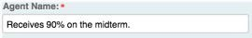
- In the description box, describe the intelligent agent. This is only seen by you.
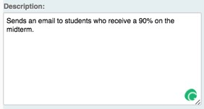
- Skip the “Agent is enabled” box for now. We will come back and check this when it is finished.

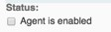
- There are three general options for intelligent agents. The first option is to set it to email when a student has or has not logged in to D2L for a certain number of days. This option is not course specific. It applies to a general D2L login, whether they enter your course or not. To do this, check the login activity box, then choose whether it should apply to them having logged in or not having logged in, and set the number of days.
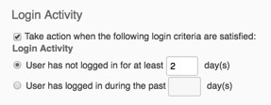
- The second option is to set it to email when a student has or has not accessed your course for a certain number of days. This option is course specific. It applies to your course specifically in D2L. To do this, check the course activity box, then choose whether it should apply to them having accessed or not having accessed the course, and set the number of days.
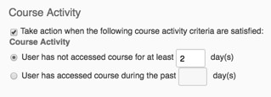
- The third option is to set it to email when a student satisfies any other condition in the course. To access the options for this, click Create and Attach.
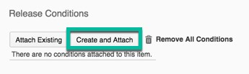
- After clicking Create and Attach, you will be prompted to choose a condition type, and then to set the condition details. There are a lot of options to choose from, and each of them has its own settings.

- After you choose the condition type and set the details, click Create.
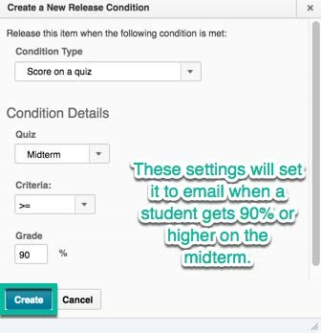
- Next you will choose the repetition of the emails. You can set it to only email the first time the condition occurs or you can set it to email each time the agent is evaluated and the condition occurs for the student. See the next step for more information about the frequency with which the agent is evaluated.
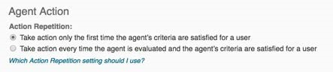
- The next step is to set the schedule for the intelligent agent. There are a couple of options here. If you check the box and set a schedule, the agent will run on that schedule and send the emails as set by the previous step. However, if you do not check it, you have to run the agent manually when you want it to run. To set a schedule, check the box and click Update Schedule.
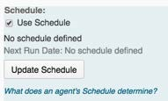
- Set the schedule settings according to how often you want the agent to run, and set a start and end date as needed. When you are finished, click Update.
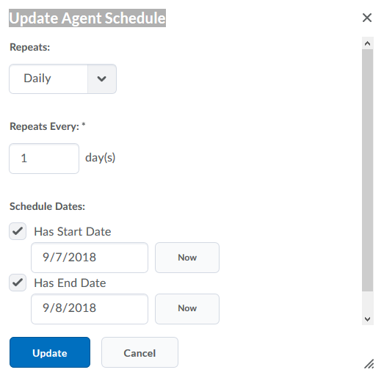
- You can choose whether to write the email in HTML or plain text next. Hint: HTML will give you the option to change font sizes, colors, etc. and plain text will not.
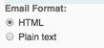
- Next you will come to a traditional email form. In the To box, you will need a special code so that the email is only sent to specific students who initiate the intelligent agent. There are two codes to do this, and they are actually stored in the form for you so that you don’t have to remember them. The link that says “What special email addresses can I use?” under the BCC box.
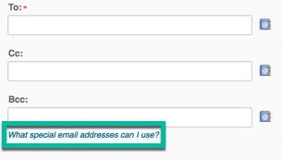
- That will bring up a box with codes on it. The first one, {InitiatingUser}, will be what you want to put in the To box to have it email the student who initiates the intelligent agent.
- Below the email subject line, you will see another link for replacement strings. Click that to see the codes you can use in the subject and email body to personalize the email. For example, you can have the email say “Hello {InitiatingUserFirstName},” where the blank fills in the student’s first name.
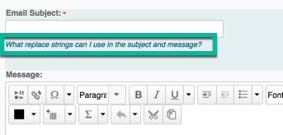
- Fill in the subject and message boxes with the email subject and body.
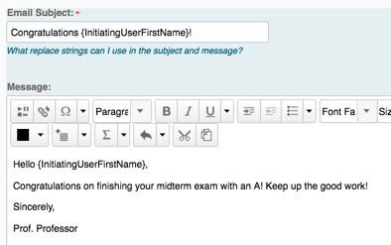

What are replacement strings?
Replacement strings are special symbols or tokens that D2L looks for when preparing text to display or email. Replacement strings can be identified by text wrapped in curly braces ("{" and "}"). A replacement string {OrgUnitName} in D2L is converted by D2L to show the name of a course.

Using replacement string in an agent
Intelligent Agents can use replacement strings to personalize email messages. For example, instead of writing an Intelligent Agent body that is generic, the opening of a message might have "Dear {InitiatingUserFirstName}". The student that triggers an agent would see their first name in their email rather than "{InitiatingUserFirstName}".

Valid replacement strings
While many areas of D2L use replacement strings, Intelligent Agents has unique strings that will only work in the Intelligent Agents tool.
List of Replacement Strings
Replace String | Description | For Use In
{InitiatingUser} | The user who performs the action that meets the agent’s criteria | Email address field
{InitiatingUserAuditors} | The auditors for the user who performs the action that meets the agent’s criteria | Email address field
{OrgName} | The name of the organization ("UW-Milwaukee") | Email body
{OrgUnitCode} | The code for the Org Unit (typically the code listed in My Courses and Course Offering Information) | Email body
{OrgUnitName} | The name of the Org Unit (typically the name of a course in Course Offering Information) | Email body
{OrgUnitId} | The org unit ID required to make quicklinks works | Email subject line and email body
{InitiatingUserFirstName} | The first name of the initiating user | Email body
{InitiatingUserLastName} | The last name of the initiating user | Email body
{InitiatingUserUserName} | The username of the initiating user | Email body
{InitiatingUserOrgDefinedId} | The Org Defined ID of the initiating user | Email body
{LastCourseAccessDate} | The date the initiating user last accessed the course | Email subject line and email body
{LastLoginDate} | The date the initiating user last logged in | Email subject line and email body
{LoginPath} | The address of the login path for the site | Email body

- When you are finished with your intelligent agent, scroll back up to the Status section and check the box to enable it. Then click Save and Close at the bottom.
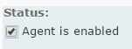
- If you did not set a schedule, you will need to manually run your agent. To do that, click the arrow next to your agent, then click Run Now.
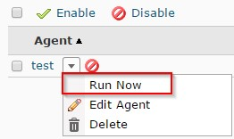
- Click on Settings on the Agent List.

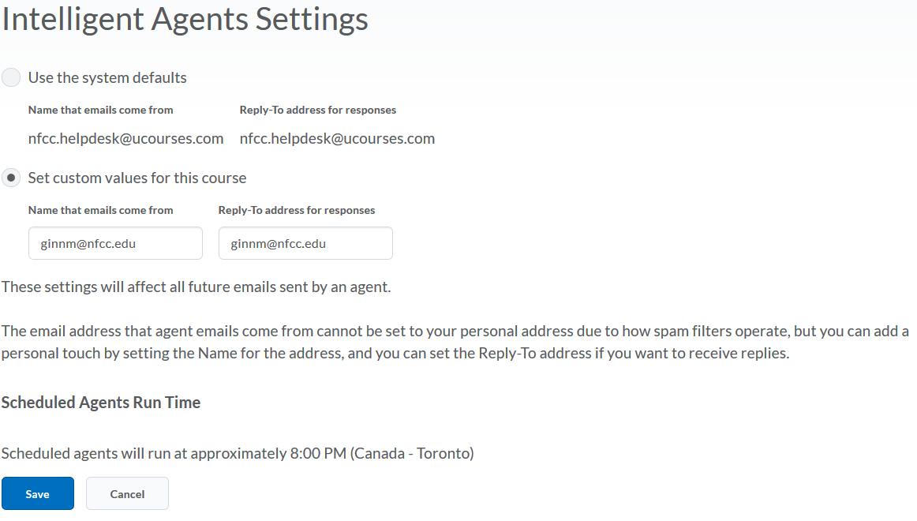

References:
D., D. (2017). D2L Intelligent Agents - Dynamic Agent Email with Replacement Strings. Retrieved from https://kb.uwm.edu/page.php?id=76050
Reardon, T. (2016). Intelligent Agents in D2L. Retrieved from http://distanceed.hss.kennesaw.edu/elearning/tutorials/IntelligentAgents.pdf

