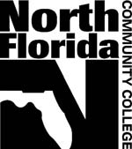
North Florida Community College
MASTER SYLLABUS

COURSE TITLE:
COURSE NUMBER: | NUMBER OF CREDIT HOURS:
PREREQUISITES: | COREQUISITES:
REQUIRED TEXT:

OTHER REQUIRED MATERIALS:

ADDITIONAL RECOMMENDED MATERIALS OR RESOURCES:

COURSE DESCRIPTION:

Program Outcomes OR General Education Competencies:

Course Level SLO # | Program Outcomes or Gen Ed Competencies | Required Common Summative Assessments

SUGGESTED METHODS OF ASSESSMENT:

