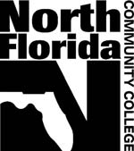North Florida Community College
MASTER SYLLABUS

COURSE TITLE:
COURSE NUMBER: | NUMBER OF CREDIT HOURS:
PREREQUISITES: | COREQUISITES:
REQUIRED TEXT:

OTHER REQUIRED MATERIALS:

ADDITIONAL RECOMMENDED MATERIALS OR RESOURCES:

COURSE DESCRIPTION:

EXPECTED LEARNING OUTCOMES:

Learning  Outcome  Number | General  Education  Competencies | RELATED ASSESSMENTS

REQUIRED ASSESSMENTS:

SUGGESTED METHODS OF ASSESSMENT:

